Introduction to the WTP SaaS Application

A SaaS-in-a-Box Tutorial

This tutorial walks you through deploying the Wingtip Tickets Platform (WTP) SaaS application. The application uses a database-per-tenant, SaaS application pattern, to service multiple tenants. The application is designed to showcase features of Azure SQL Database that enable SaaS scenarios, and SaaS design and management patterns.

Five minutes after clicking the Deploy to Azure button below, you’ll have a multi-tenant SaaS application up and running in the cloud. The application is deployed with three sample tenants, each with its own database, all deployed into an elastic pool. The application allows new tenants to sign-up for the WTP service, which automatically provisions new tenant databases into the pool.

In this tutorial, you learn how to:

* Deploy the WTP application. The app is deployed to your Azure subscription, giving you full access to inspect and work with the individual application components.
* Explore the application and application architecture in the Azure portal. Browse the web apps, servers, pools and databases that make up the app.
* Sign up and configure new customers (tenants).
* Delete the application and all resources created with it to stop billing in Azure.

The application once installed can be used with a series of related tutorials that use it to explore various SaaS design and management patterns.

**IMPORTANT.** Your subscription will be billed for all application resources created. It is quick to deploy and easy to delete, so it’s recommended that you delete the application when you finish a tutorial session, and deploy it again later when you want to try out other tutorials.

Deploy the WTP SaaS Application

1. Click to deploy!

[Deploy to Azure](https://portal.azure.com/#create/Microsoft.Template/uri/https%3A%2F%2Fwtpdeploystorageaccount.blob.core.windows.net%2Ftemplates%2Fazuredeploy.json)  
(<http://aka.ms/deploywtpapp>)

1. Enter required parameter values for the deployment:

**IMPORTANT** Some authentication, and server firewalls are intentionally wide-open for demonstration purposes. Do not use existing resource groups, servers, or pools, and do not use this application, or any resources it creates, for production. You should **create a new resource group**. Deleting this resource group when you are finished with the application will delete all the application-related resources and stop billing.

* + Resource Group. Select **Create new** and provide a **Name** and **Location**. The location is used for the resource group and all application resources.
  + User. Provide a **User** value which will be used to differentiate resources you create from those created by others deploying this application.

**NOTE**: It’s recommended to use a short User name, such as your initials plus a number (e.g. bg1), and then use that in the resource group name (e.g. wingtip-bg1). If you increment the number if you redeploy the app it will be easy to recognize the resource group and its resources.

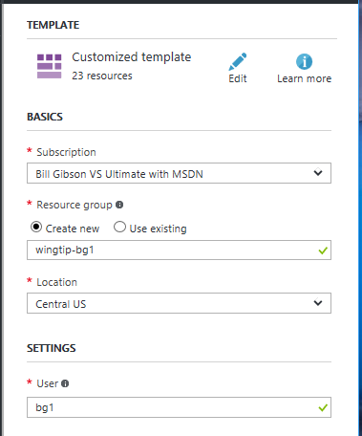

1. **Deploy the application**.
   * Click if you agree to the terms and conditions.
   * Click **Purchase**.
2. Monitor deployment by clicking **Notifications** (the bell icon right of the search box). Deploying the WTP app takes approximately 4 minutes.

**NOTE** If you get errors, try deploying again with a different **User** value. The **User** parameter is used as part of server, web app names, etc., some of which need to be globally unique. The **User** parameter can contain only letters, numbers, and hyphens. The first and last character must be a letter or a number, lowercase is recommended.

Initialize the tenant catalog

Deploying creates the WTP application, and three sample tenants. The application uses the database-per-tenant model, so a database is created for each sample tenant. During normal application use, tenant databases are registered in the customer catalog when new tenants are provisioned. Because the sample tenant databases bypass the provisioning process, and are created during app deployment, we must manually register them.

**IMPORTANT!** The following steps are required to initialize the catalog and register the sample databases in the **customercatalog** database, and only need to be run once after deployment.

1. Start the **Demo Assistant** by browsing to the following URL (replace <USER> with the User you set previously during deployment): http://demo.wtp.<USER>.trafficmanager.net
2. Click **Setup**:

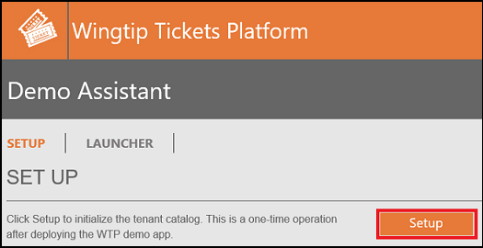

Explore the application

The app targets venues, such as concert halls, jazz clubs, sports clubs, that host events. Venues register as customers (or tenants) of the Wingtip Tickets Platform (WTP), for an easy way to list events and sell tickets. Each venue gets personalized web apps to manage their events and venues, list events and sell tickets independently, and isolated from other tenants.

Click **LAUNCHER**

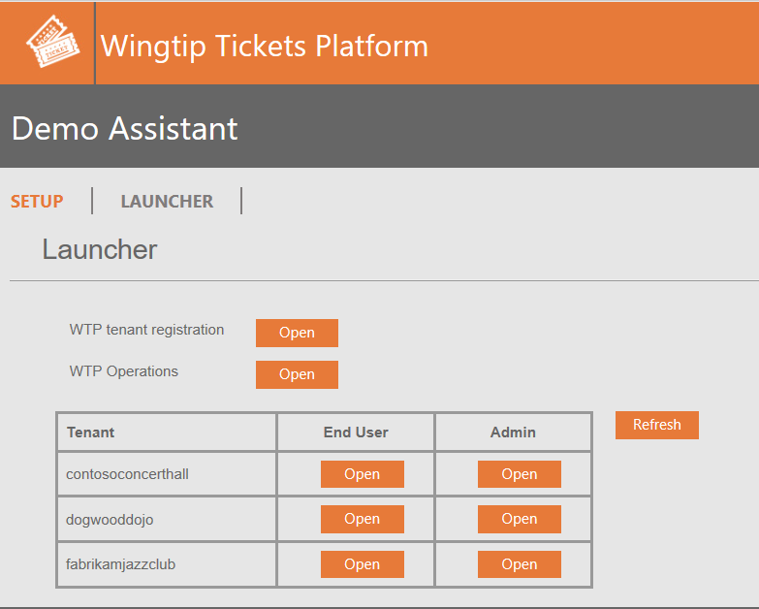

The Launcher provides a centralized list of the application URLs:

**WTP apps**

* **WTP tenant registration** (*register* app - http://register.wtp.<USER>.trafficmanager.net/) - For new customers to register to sell tickets on the WTP platform.
* **WTP Operations** (*operations* app - http://operations.wtp.<USER>.trafficmanager.net/) - For WTP devops to manage all their tenants.

**Tenant apps** - These must connect to the correct tenant database so the tenant name is passed in each URL.

* **End User** (*events* app - http://events.wtp.<USER>.trafficmanager.net/<TENANT>) - For tenant's customers to browse events and buy tickets.
* **Admin** (*admin* app - http://admin.wtp.<USER>.trafficmanager.net/<TENANT>) - For tenant administrators to manage their events and venues.

**TIP**: Use ctrl-click to open links in a new tab, so you can keep the launcher open. Don’t see the tenant you just added? Click on Refresh to update the list after adding new tenants.

Browse to the Fabrikam Jazz Club events (events app)

1. Ctrl-click **End User > Open** in the *Launcher* to open the Fabrikam events page in another tab: http://events.wtp.<USER>.trafficmanager.net/*fabrikamjazzclub*
2. Click **Tickets**.

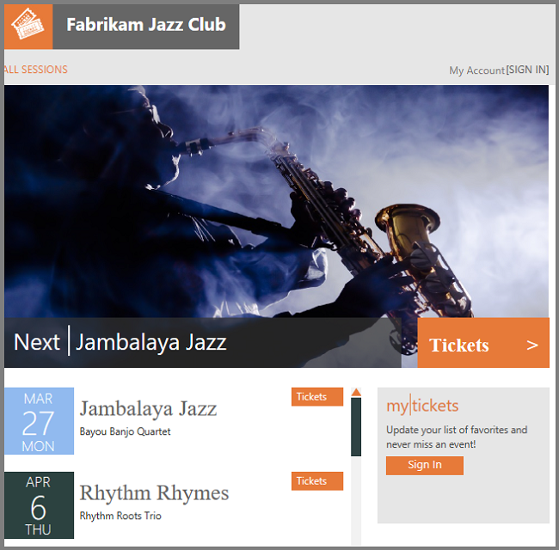

The WTP application uses [Azure Traffic Manager](https://docs.microsoft.com/azure/traffic-manager/traffic-manager-overview) to control the distribution of traffic. The events pages, which are tenant-specific, require that tenant names are included in the URLs. The events app parses the tenant name out of the URL path and uses it to create a key that is used to access a catalog implemented using [shard map management](https://docs.microsoft.com/azure/sql-database/sql-database-elastic-scale-shard-map-management). The catalog maps the key to the tenant’s database location.

Note that in a production environment, you would create a CNAME DNS record to [point a company internet domain](https://docs.microsoft.com/azure/traffic-manager/traffic-manager-point-internet-domain) to the traffic manager profile.

Sign up a new tenant - register a venue to sell tickets (register app)

In this section, a new customer registers their venue on the WTP platform to sell tickets to their events.

1. In the **Demo Assistant**, ctrl-click **WTP tenant registration** > **Open**. (*http://register.wtp.<USER>.trafficmanager.net*)
2. Click **Register**, and provide a **Venue name**, and **Postal code**. The **Administrator** and **Password** fields are intentionally non-editable.
3. Click **Submit**, and a new tenant is provisioned and registered in the catalog using a key based on the venue name, and URLs are provided that you can use to open the admin app and the public events app:

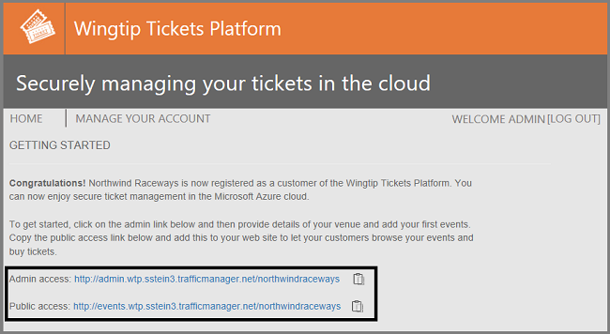

Start generating load on the tenant databases

Now that we have several tenant databases, let’s put them to work! To accomplish this, we have a PowerShell script that simulates a workload running against all tenant databases.

**IMPORTANT**: Before running PowerShell scripts, open the user configuration file (*...\Learning Modules\UserConfig.psm1*) and set the resource group name and user name you used when deploying the application. You must modify this file if you redeploy the app with different values.

1. Open the PowerShell ISE, and load the load generator demo script: *(..\Learning Modules\Utilities\Demo-LoadGenerator.ps1*)
2. Press **F5** to run the script and start the load generator.

**NOTE** The load will run for 60 minutes by default. As this is a SaaS app, tenant activity would typically be sporadic and unpredictable. To simulate this the load generator produces a randomized load distributed across all the tenants. Because of this, it needs a few minutes for the pattern to emerge.

Tenant Admin (admin app)

New tenants provisioned by the register app are created with the default *Multi-Purpose* venue type. The admin app lets a venue admin configure their venue, and provide a more appropriate venue type:

1. Either click on the admin link on the confirmation page or, in the **Launcher**, click refresh to make sure you see the new tenant and then ctrl-click the **Admin access** link (*http://admin.wtp.<USER>.trafficmanager.net/<VENUENAME>*) to open the tenant administration page, and click **Venue**

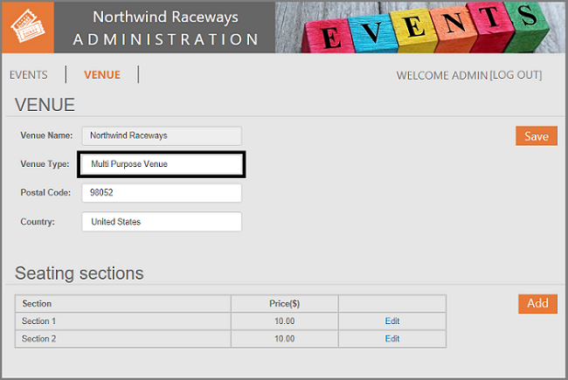

1. Change the **Venue Type** to **Motor Racing** and click save. Changing the venue type changes the image in the header and the background image of the venue’s events page.

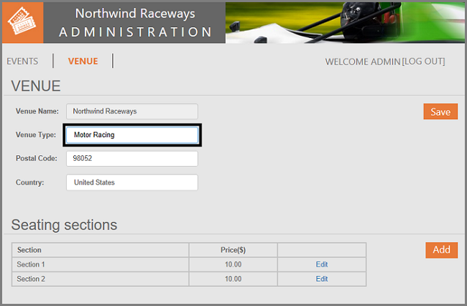

1. You can also use the admin app to configure the venue seating, add events, and set ticket prices.
2. Now you’ve configured the venue use the Launcher to ctrl-click to open the events (end user) page to see the full effect.

WTP devops (operations app)

The WTP Operations app is used by the devops and support team in WTP to manage tenants. The app uses extended metadata in the catalog to retrieve the tenant’s name associated with each database. This can be used to quickly get to the right database to aid in troubleshooting or support calls.  *http://operations.wtp.<USER>.trafficmanager.net/.*

1. In the **Launcher**, ctrl-click *WTP Operations* > **Open**

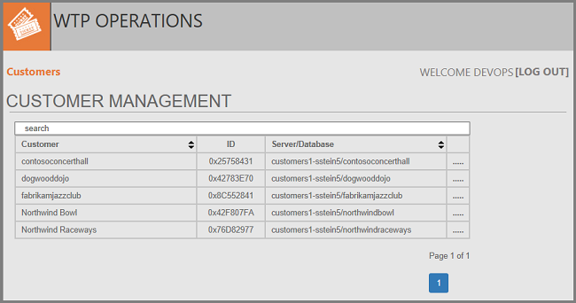

Explore the servers, pools, and tenant databases

Now you have explored the application, let’s look behind the scenes at the resources that were deployed.

1. In the [Azure portal](http://portal.azure.com), open the **catalog-<USER>** server. The catalog server contains 2 databases; the customercatalog, and the baseTenantDB (an empty db that is copied to create new tenants).

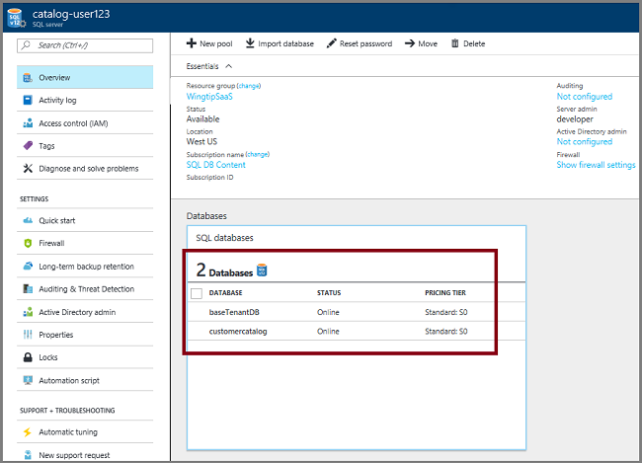

1. Open the **customers1-<USER>** server which holds the tenant databases. Note that each tenant database is an Elastic Standard database in a 50 eDTU standard pool.

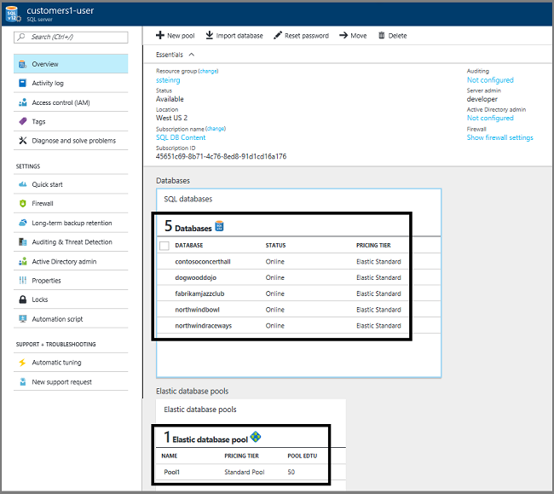

Monitor the pool

By this time, the load generator should have been running for several minutes, so enough telemetry should be available to start looking at the monitoring capabilities built into pools and databases.

1. On the server customers1-<USER>blade, click **Pool1** to view resource utilization for the pool:

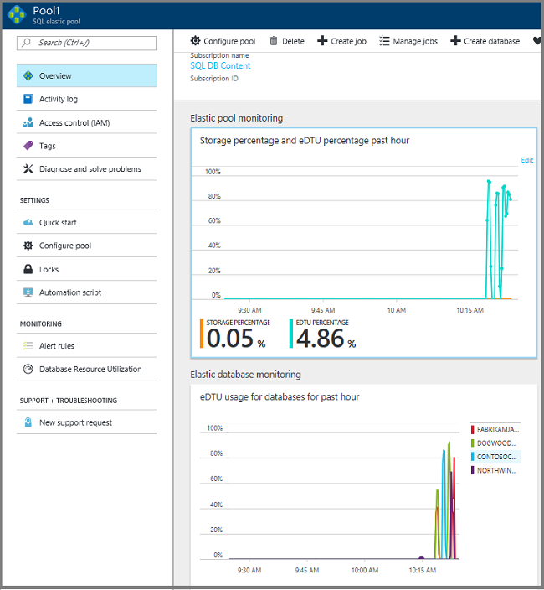

What these two charts nicely illustrate is how well suited elastic pools and SQL database are for SaaS application workloads. Five databases that are each bursting to as much as 40 DTUs are easily being supported in a 50 DTU pool. If each was provisioned as a standalone database, they would each need to be an S2 (50 DTU) databases to support the bursts, yet the cost of 4 standalone S2 databases would be nearly 3 times the price of the pool. And the still has plenty of headroom for many more databases. In real-world situations, customers are currently running up to 500 databases in 200 eDTU pools.

Want to learn more about SaaS applications?

A series of tutorials is provided that accompany the WTP app which each explores a different set of SaaS patterns through hand-on exercises that lead you through sample scripts and templates. Each exercise is quick to do and the tutorials can be followed in any order. To locate the tutorials look in the folders beneath …\Learning Modules\ .

Deleting the resources created with this tutorial

When you are finished exploring and working with the WTP app, browse to the application's resource group in the portal and delete it to stop all billing related to this deployment. If you have used any of the accompanying tutorials, any resources they created will also be deleted with the application.

Other resources

* To learn about elastic pools, see [What is an Azure SQL elastic pool](https://docs.microsoft.com/azure/sql-database/sql-database-elastic-pool)
* To learn about elastic jobs, see [Managing scaled-out cloud databases](https://docs.microsoft.com/azure/sql-database/sql-database-elastic-jobs-overview)
* To learn about multi-tenant SaaS applications, see [Design patterns for multi-tenant SaaS applications](https://docs.microsoft.com/azure/sql-database/sql-database-design-patterns-multi-tenancy-saas-applications)